**Battle of Neighborhoods**

***IBM Applied Data Science Capstone Project***

**Guillermo Del Castillo**

# Introduction

* 1. **Background**

Quito is the capital of Ecuador, the country's most populous city, and at an elevation of 2,850 metres (9,350 ft) above sea level, it is the second-highest official capital city in the world.

The historic centre or Old Town of Quito is one of the largest, least altered and best-preserved in the Americas. A monument and museum marking the general location of the equator is known locally as la mitad del mundo (the middle of the world.

Quito tourism numbers exceeded half a million visitors in the first nine months of 2019, 48% of all arrivals in Ecuador, which is 5% more than the number of visitors recorded in the first nine months of the previous year.

For entrepreneurs looking to investing in business like specialty cafes and restaurants would be a great opportunity considering the locals and tourist visitors.

* 1. **Problem**

To choose the best location of the city we need to compare the neighborhoods particularly the “new” downtown where most business of the financial district are located, and the historic center or Old Town. We will need to find out where are most business located and their categories to find out the best business opportunity.

# Data

I will briefly describe the two neighborhoods selected for the comparison.

**Quito downtown**

This is the modern Quito, with high-rise buildings, shopping centers, the financial district, and upper-class residential areas and some working-class housing areas. This modern area is the city's entertainment hub. It is a meeting point for both residents and tourists. Its cosmopolitan atmosphere is expressed in a wide variety of culinary, artistic, and cultural options, and the large number of hotels, inns, travel agencies, shops, bars, and discothèques that light up when the sun sets.

**Quito Historic Centre – Old Town**

Quito has the largest, least altered, and best-preserved historic center in the Americas. This center was, together with the historic center of Kraków in Poland, the first to be declared a World Heritage Site by UNESCO on 18 September 1978. There are about 130 monumental buildings (which host a variety of pictorial art and sculpture, mostly religiously inspired, in a multi-faceted range of schools and styles), and 5,000 properties registered in the municipal inventory of heritage properties.

**Foursquare API:**

I will be using the Foursquare API to explore the nearby venues for both neighborhoods to find the most accurate place to open the Shop. I looked for venues up to **2km** range from the latitude and longitude of neighborhoods

From the foursquare API, I will be retrieving the following for each nearby venue:

* Name
* Category
* Latitude
* Longitude

# Methodology

First, to start working in the project, we needed to choose the main location we want to compare. To get the coordinates I used the python library Nominatim by including the city location as parameter.

To be able to use foursquare API and look for the nearby venues we had to create a foursquare developer account to have a personal API key. We can get the name, category, latitude, and longitude of the venue using the API.

To start exploring the nearby venues, we have put radius as 2000 meters (2 KM) around the main venues. And a limit of 100 venues so it can be easy to deal with and compare.

After getting the nearby venues, I wanted to see the unique categories we have near the two neighborhoods. To be able to filter the kind of venues we are looking for.

Also, I have been able to create clusters per each location to visually see the venues density in order to have a more in-depth analysis.

# Results

**Quito Downtown**

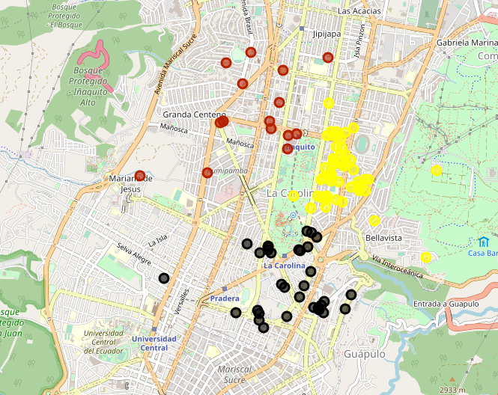

**Quito Historic Center – Old Town**

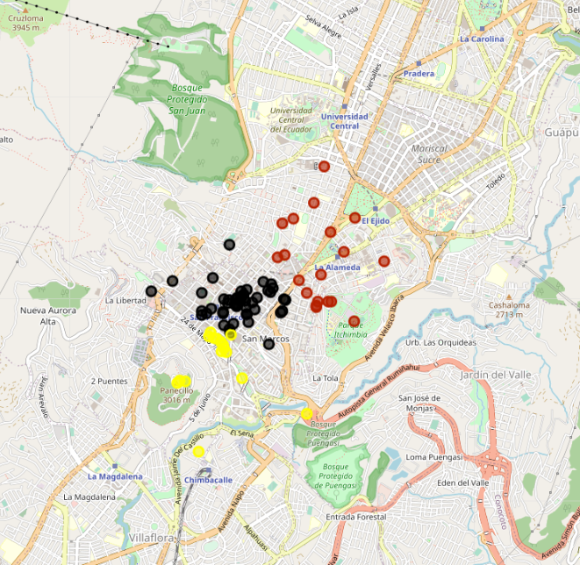

We put the categories in a separate data frame to be able to visualize them in a bar chart.

**Quito Downtown**

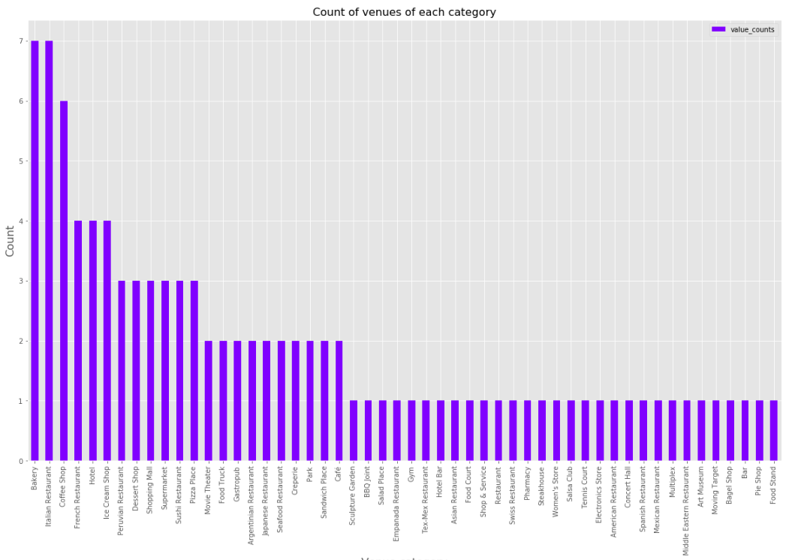

**Quito Historic Center – Old Town**

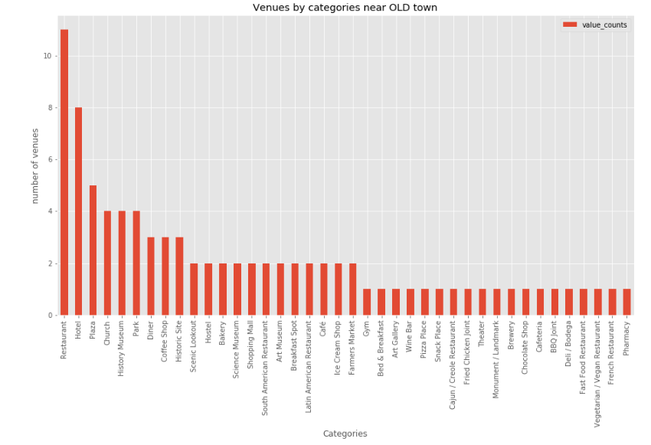

As we see above, coffee shop is the highest category for both neighborhoods, and is its number is way haigher than other categories. We can see that there are coffee shops category and Café category, but I am going to treat them as one, as they both serve coffee.

**Quito Downtown**

The results are 32 restaurants of different cuisines and 13 coffee shops or similar in downtown

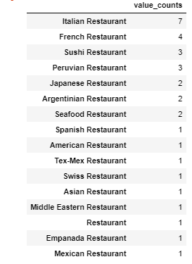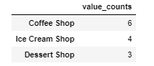

**Quito Historic Center – Old Town**

The results are 19 restaurants of different cuisines and 6 coffee shops or similar.

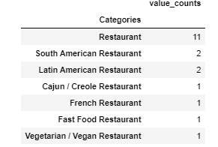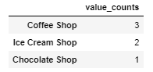

# Conclusions

We can see that opening a cafe in Quito - Old Town is a better option according to the high number of coffee shops in downtown.

Also, the high presence of hotels, historic sites, museums in the Old Town suggest high numbers of visitors with few coffee shops options, making this a great business opportunity.

# Resources

<https://en.wikipedia.org/wiki/Quito>

<https://github.com/gdelcast/Coursera_Capstone>

<https://github.com/gdelcast/Coursera_Capstone/blob/master/Battle%20of%20the%20neighborhoods/Battle%20of%20the%20neighborhoods-FinalReport.ipynb>